

**Our Ocean Conference BackOffice**

**User Manual**

**HOST**

Version 2.0

Brussels, April 2020

**TABLE OF CONTENTS**

**Access the application** **3**

**Register** **3**

Who can register? 3

How to register? 3

**Reset Password** **3**

**Sign in** **4**

**Sign out** **4**

**Profile** **4**

How to complete your profile? 4

Your personal profile 5

Your organisation profile 5

**Invite a colleague** **5**

**Manage commitments** **6**

How to add comments to a commitment? 6

Add a private comment 6

Add a public comment 7

How to approve a commitment? 7

How to request more information to the POC? 9

How to reject a commitment? 9

How to schedule a commitment for publication? 10

How to publish commitments? 10

How to search commitments? 11

How to export a list of commitments? 12

**Manage users** **12**

How to approve a user? 12

User by user 13

Multiple users 13

How to reject a user? 13

User by user 14

Multiple users 14

How to delete a user? 14

User by user 14

Multiple users 15

User by user at the organisation level 15

How can I edit the information of a user? 16

How give Host privileges to a user? 16

User by user 16

Multiple users 17

How remove Host privileges from a user? 17

User by user 17

Multiple users 18

How to search users? 18

How to export a list of users? 19

**Manage organisations** **19**

How to edit the information of an incomplete organisation profile? 19

How to delete unused organisations? 20

How to merge two organisations? 20

How to search organisations? 21

How to export a list of organisations? 22

**Track a campaign progress** **22**

**Manage application settings** **24**

Manage Host settings 24

Edit Host settings 24

Create a campaign 25

Manage organisation types 26

Edit an organisation type 26

Add a new organisation type 26

Delete an organisation type 26

Manage commitment themes 27

Edit an existing commitment theme 27

Add a new commitment theme 27

Delete a commitment theme 28

Manage map viewer configurations 28

Manage the publishing scheduler 29

**Annex A - Commitment Workflow** **31**

# **Access the application**

The application is available online through the following URL:

<https://ouroceanconference.org/hosts/login>

# **Register**

## **Who can register?**

Only invited users can register themselves. They will be automatically linked to the hosting organisation.

## **How to register?**

1. Follow the link you received in the email
2. Fill in the form

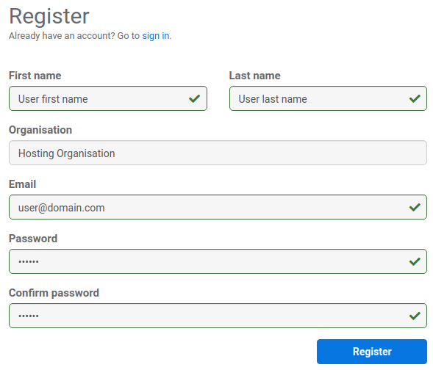

1. Click on the *Register* button
2. Wait for the confirmation email

# **Reset Password**

In case you forgot your password you can create a new password following the next steps:

1. Click on Forgot my password



1. Enter your email address and press the *Reset* button
2. You will receive an email containing a link to reset your password
3. Click the link and enter your new password
4. Press the *Reset* button

You have now changed your password.

# **Sign in**

To sign in enter your email address and your password and press the *Sign in* button.



# **Sign out**

To sign out click on the cog icon in the top right of the screen and select *Sign out*.



# **Profile**

## **How to complete your profile?**

To be able to manage commitments you need to complete your personal and organisation profiles.

### **Your personal profile**

1. Click on the cog icon in the top right of the screen and select *My profile*



1. Click on the *Edit* button
2. Complete any missing information

**\*** First name, last name and phone number are mandatory fields.

1. Click on the *Update* button

### **Your organisation profile**

1. Click on the cog icon in the top right of the screen and select *My organisation*



1. Click on the *Edit* button
2. Complete any missing information

**\*** Organisation name, entity type, address, postal code, city and country are mandatory fields.

**\*** The application will try to automatically geocode your address and display its location on the map. You can, nevertheless, adjust the position by dragging the blue pin on the map.

1. Click on the *Update* button

# **Invite a colleague**

You can easily invite other colleagues belonging to your organisation by following the next steps:

1. Click on the cog icon in the top right of the screen and select *My organisation*



1. Click on the *Invite a colleague* button
2. Enter the email of your colleague

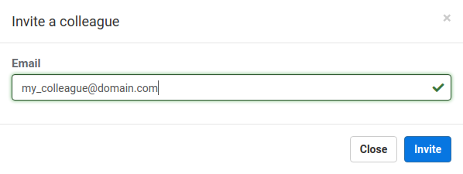

1. Click on the *Invite* button

# **Manage commitments**

There is a predefined workflow associated with commitments, from their creation, to approval, publishing, progress updating and closing. Please refer to the Annex A to better understand the entire workflow.

To be able to manage commitments your personal and organisation profiles must be completed and valid. All management tasks related to commitments are made available in the *Manage commitments* tab of the dashboard.

## **How to add comments to a commitment?**

At any point in time, in the whole lifecycle of a commitment, the host can add additional comments on the commitment itself. This can be useful, for instance, if a HOST user wants to add comments for other HOST users to see (this is a private comment). Another use might be if the HOST wants to further communicate with the POC that was made the commitment (this is a public comment).

Following the same steps as described above you will be able to add comments to the commitment:

1. Click on a row displaying the commitment to which you want to add a comment
2. Click on the *Add comment* button in the top right of the screen



### **Add a private comment**

A private comment is only visible to HOST users. This can be used like an internal communication tool on a per commitment basis.

After clicking on the *Add comment* button, a new window is presented:

1. Type your comment
2. Make sure you uncheck the option *is publicly visible*
3. Press the *Submit* button



### **Add a public comment**

A public comment is visible to both HOST and POC users. This can be used to request additional information to the POC user. Whenever a public comment is made, an email is sent out to the POC user that has last edited the commitment.

After clicking on the *Add comment* button, a new window is presented:

1. Type your comment
2. Make sure you check the option *is publicly visible*
3. Press the *Submit and send to POC* button



## **How to approve a commitment?**

Whenever a new commitment is submitted by a POC, you will see a notification on the commitments tab of your dashboard indicating how many commitments need your attention.



Another possibility to find all commitments that need to be approved is by using the *Status* filter on the left so that only the submitted commitments are listed on the table.

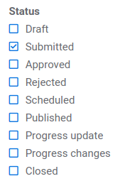

Once you have found the commitments that were submitted for approval, you will need to approve them one by one.

1. Click on a row displaying a commitment that needs approval
2. Click on the *Approve* button in the top right of the screen



1. If you wish, you can add a comment and press the *Submit* button

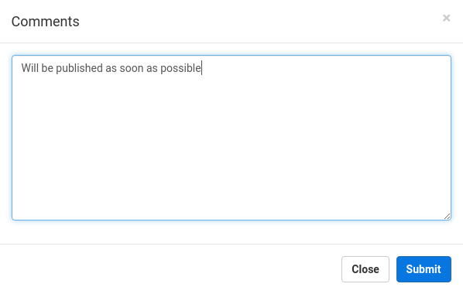

Once you approve a commitment an email will be sent out to the POC that has made the request for approval.

## **How to request more information to the POC?**

When a commitment is submitted by a POC for your approval, you are able to request for more information (for example, requesting a better description). Following the same steps as described above you will be able to make this request.

1. Click on a row displaying a commitment that needs approval
2. Click on the *Changes requested* button in the top right of the screen



1. Enter your comments specifying what you are requesting and press the *Submit* button

An email will then be sent out to the POC with your comments. He will then need to make the necessary changes and resubmit his commitment for approval.

## **How to reject a commitment?**

A commitment can be rejected if you think it doesn't fit the necessary standards within the OOC scope. Once you reject a commitment it will be blocked from further editing and no more actions can be taken upon this commitment.

Following the same steps as described above you will be able to make this request.

1. Click on a row displaying a commitment that needs approval
2. Click on the *Reject* button in the top right of the screen



1. Enter your comments specifying why the commitment is being rejected and press the *Submit* button

## **How to schedule a commitment for publication?**

Before publishing a commitment you will need to set a date defining the minimum date from which the commitment can be made publicly available. You will need to set this date on each and every commitment. This is typically done only once after approving a commitment. To find all commitments that need to be scheduled for publishing you can simply set the *Status* filter to display only the approved commitments.

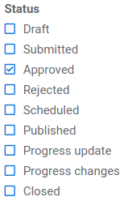

You will then need to open the displayed commitments one by one and set the schedule date.

1. Click on a row displaying a commitment that needs to be scheduled
2. Click on the *Schedule Publication* button in the top right of the screen
3. If you wish you can add any additional comment, set the schedule date and click on the *Submit* button

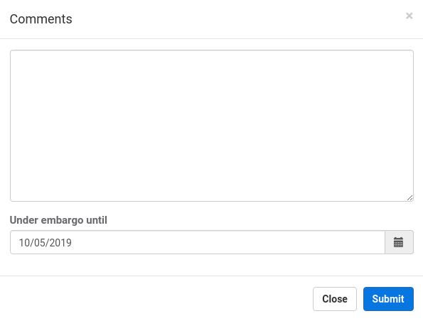

## **How to publish commitments?**

The publishing process is applied to all eligible commitments. This means that every time a publishing event happens all commitments that have the status of *scheduled*, *published*, *progress update* and *closed* will be (re-)published and uploaded to the publicly available frontend application.

You can publish commitments in two ways:

1. By manually triggering a publishing event
2. By configuring an automated scheduler job (covered in a later chapter)

To manually publish commitments:

1. Go to the *Manage commitments* tab in the dashboard
2. Click on the *Publish Now* button in the top right of the screen



## **How to search commitments?**

You can search all commitments in the *Manage commitments* tab of the dashboard through the combined use of several filters:

* Text search field, that will search within the commitment’s title, abstract and impact.



* Area of action checkbox section, where you can select one or multiple themes

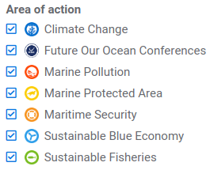

* Year combobox, where you can select either a specific year or all

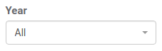

* Progress combobox, where you can select either a specific progress percentage or all

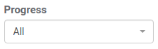

* Status checkbox section, where you can select one or multiple status of commitments

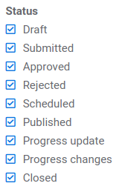

Whenever you change one of these filters a new search is performed and only the commitments matching your search criterias will be displayed in the table.

## **How to export a list of commitments?**

You can export a list containing all commitments that match your searching criterias. This list is a comma separated value (CSV) file containing the commitment’s year, type, title, budget, progress and other information. The separator used is a tab. To export the list of commitments simply go to the *Manage commitments* tab of the dashboard and click on the export button.



# **Manage users**

All managing tasks related to users are made available in the the *Manage users* tab of the dashboard.

## **How to approve a user?**

Whenever a new user registers, you will see a notification on the users tab of your dashboard indicating how many users need your attention.



Another possibility to find all users that need to be approved is by using the *Status* filter on the left so that only pending approval users are listed on the table.

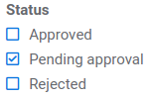

Once you have found the users that need approval, you can approve them in three ways.

### **User by user**

1. Click on a row displaying a user that needs approval
2. Click on the *Approve* button in the top right of the screen



### **Multiple users**

1. Select multiple users in the table
2. Click on the *Actions* button and select *Approve*



An email will be sent out to each and every user that was approved informing that he can now log in to the application.

## **How to reject a user?**

A user can be rejected at any time. Rejecting a user will disable him from logging in to the application. Use the available filters to search for the users you want to reject. Once you have found them, you can reject them in two ways.

### **User by user**

1. Click on a row displaying a user that needs approval
2. Click on the *Reject* button in the top right of the screen



### 

### **Multiple users**

1. Select multiple users in the table
2. Click on the *Actions* button and select *Reject*



## **How to delete a user?**

A user can be deleted at any time. Deleting a user will disable him from logging in to the application. A user should be deleted when, for example, leaves an organisation and should no longer have access to the system. This users can be re-approved at any point in time. Use the available filters to search for the users you want to reject. Once you have found them, you can delete them in three ways.

### **User by user**

1. Click on a row displaying a user that needs approval
2. Click on the *Delete* button in the top right of the screen



### **Multiple users**

1. Select multiple users in the table
2. Click on the *Actions* button and select *Delete*



### **User by user at the organisation level**

1. In the dashboard, select the *Manage organisations* tab
2. Use the filters to find a specific organisation and click on the row displaying it
3. On the *Organisation profile* page, you will be able to delete user by user through the *Delete* button



Deleted users can be added again to the same organisation at any time. You can simply expand the *Show deleted users* section and press the *Approve* button in the specific user you want to re-add.



## **How can I edit the information of a user?**

1. Use the filters to find the user you want to edit
2. Click on the row displaying the user you are interested in
3. Click on the *Edit* button
4. Modify the information you wish to change
5. Click on the *Update* button

## **How give Host privileges to a user?**

A user can be granted Host privileges at any time. This means that the user will be able to login into the application as a Host and, therefore, be able to manage commitments, users and organisations. Use the available filters to search for the users you want to grant Host privileges to. Once you have found them, you can proceed in two ways.

### **User by user**

1. Click on a row displaying a user that needs to be given privileges
2. Click on the *Edit* button and select the option *Has host privileges*



1. Click on the *Save* button

### **Multiple users**

1. Select multiple users in the table
2. Click on the *Actions* button and select *Add to Hosts*



An email will be sent out to each and every user that is granted Host privileges informing that he can now log in to the application as a host.

## **How remove Host privileges from a user?**

Host privileges can be removed from a user at any time. This means that the user will no longer be able to login into the application as a Host and perform managing operations. Use the available filters to search for the users you want to remove Host privileges from. Once you have found them, you can proceed in two ways.

### **User by user**

1. Click on a row displaying a user that needs to be removed from hosts
2. Click on the *Edit* button and deselect the option *Has host privileges*



1. Click on the *Save* button

### **Multiple users**

1. Select multiple users in the table
2. Click on the *Actions* button and select *Remove from Hosts*



An email will be sent out to each and every user that is removed from Hosts informing that he can no longer log in to the application as a host.

## **How to search users?**

You can search all users in the *Manage users* tab of the dashboard through the combined use of several filters:

* Text search field, that will search within the user’s first name, last name and email.



* Organisation combobox, where you can select either a specific organisation or all



* Status checkbox section, where you can select one or multiple status

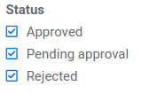

* Role checkbox section where you can select the user type role

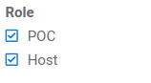

Whenever you change one of these filters a new search is performed and only the users matching your search criterias will be displayed in the table.

## **How to export a list of users?**

You can export a list containing all users that match your searching criterias. This list is a comma separated value (CSV) file containing the user’s first name, last name and emails. The separator used is a tab. This can be useful if you wish to, for example, send a general email (not supported by the application) to all users. To export the list of users simply go to the *Manage users* tab of the dashboard and click on the export button.



# **Manage organisations**

All managing tasks related to users are made available in the the *Manage organisations* tab of the dashboard.

## **How to edit the information of an incomplete organisation profile?**

An organisation profile is considered incomplete whenever there is no information about its type (e.g. Private Sector, Governmental Organisation) or its country. This organisations will be highlighted with a red exclamation mark.

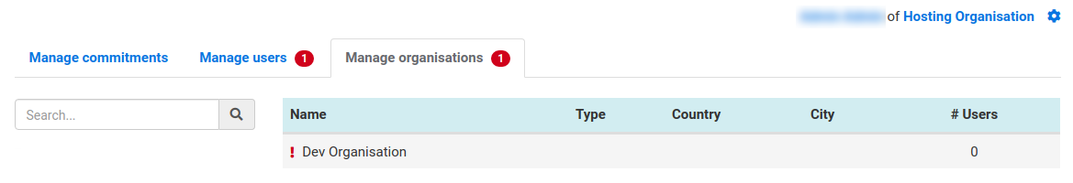

To edit an organisation:

1. Click on a row displaying the organisation to be edited
2. Click the *Edit* button
3. Complete any missing information

**\*** Organisation name, entity type, address, postal code, city and country are mandatory fields.

**\*** The application will try to automatically geocode your address and display its location on the map. You can, nevertheless, adjust the position by dragging the blue pin on the map.

1. Click on the *Save* button

## **How to delete unused organisations?**

Organisation can be deleted permanently only and only if they have no users and no commitments. In these cases, there will be a *Delete* button available in the table row representing the organisation. To delete this organisation, simply press the *Delete* button.



## **How to merge two organisations?**

There might be cases where you want to merge two organisations into one. This means merging both users and commitments into one same organisation. To merge two organisations:

1. Select two different organisations in the table
2. Click the *Merge* button



1. Select the direction of the merging operation



The arrow will display the direction of the merge, and a warning message is displayed clarifying which organisation will be deleted during the merging process.

1. Click on the *Submit* button

## **How to search organisations?**

You can search organisations through the combined use of several filters:

* Text search field, that will search within the organisation’s legal name, city and country code.



* Type checkbox section, where you can select one or multiple organisation types

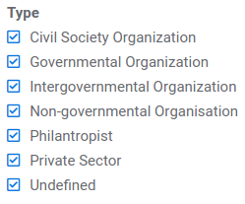

## **How to export a list of organisations?**

You can export a list containing all organisations that match your searching criterias. This list is a comma separated value (CSV) file containing the organisation’s legal name, type, country and respective number of users and commitments. The separator used is a tab. To export the list of organisations simply go to the *Manage organisations* tab of the dashboard and click on the export button.



# **Track a campaign progress**

In order to track a campaign progress you will need to first create and define a campaign under the application settings (refer to the section *Create a campaign*). An *Overview* tab will be presented in the dashboard only and only if there is an active campaign.



The *Overview* tab is divided in four sections. The first section presents you a with a timeline view where you can quickly check the start and end dates of both the campaign and conference. It also displays how many days are left until the end of the campaign

The second section presents you with statistics concerning the commitments that (should) have been updated so far. You can quickly check your progress towards the target that you defined and how many commitments were updated, closed and untouched.



The third section presents you with statistics concerning the number of new commitments achieved so far. You can quickly check your progress towards the target that you defined and how many commitments were created and in which status they are (i.e. Draft or Approved). Moreover, you can also easily view how these commitments are distributed between the different themes (i.e. Climate Change, Marine Security, etc.).

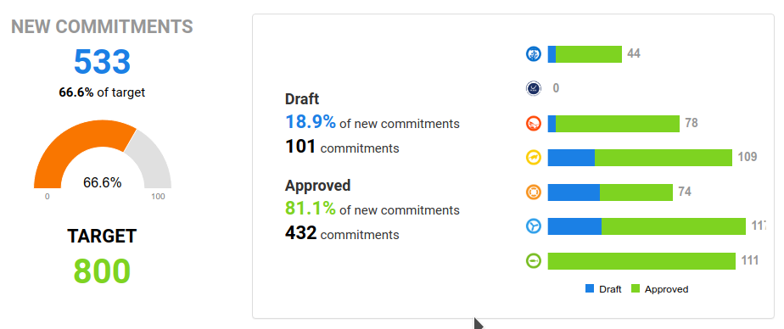

The last section presents you with statistics concerning the budget raised from new commitments so far. You can quickly check how this budget is distributed between the different types of organisations (i.e. Private Sector, Governmental Organisation, etc.) and themes (i.e. Climate Change, Marine Security, etc.).



# **Manage application settings**

There are several application wide settings that can only be managed by an host. Click on the cog icon in the top right of the screen and select *Settings*.



The application settings are organised in five different sections:

* Host
* Organisation types
* Commitment themes
* Map viewer
* Publishing scheduler

## **Manage Host settings**

In this section you will be able to set some settings related with the Conference hosting country and campaign.

### **Edit Host settings**

1. Select the *Host* tab and fill in the form:
   1. **Hosting country:** select the conference hosting country from the combobox



**\*** This option will set the flag that is seen on the header of the application.

* 1. **Official conference website URL:** enter the URL of the official conference website



**\*** This option will set the flag in the header as a clickable link that will redirect to the specified URL.

1. Click on the *Update* button

### **Create a campaign**

A campaign is used to track the progress of new commitments and updates to old commitments before the conference takes place. A new campaign should be made every year whenever the hosting team is ready to start calling POC’s to update/create commitments.

Select the *Host* tab and:

1. Activate the *Campaign active* option
2. Fill in the necessary data provided in the form:
   1. Conference start date
   2. Conference end date
   3. Campaign start date (must always be before the conference start date and after today)
   4. Campaign end date (must always be the same or after the conference end date)
   5. Target number of new commitments (the number of new commitments you wish to achieve in the campaign)
   6. Target number of updated commitments (the number of commitments you wish to be updated in the campaign)



1. Click on the *Update* button

## **Manage organisation types**

In this section you will be able to edit existing organisation types but also create new ones if needed.

### **Edit an organisation type**

1. Select the *Organisation types* tab and click on the *Edit* button for the organisation type you wish to edit



1. Change the *Label*
2. Click on the *Save* button

### **Add a new organisation type**

1. Click on the *Add type* button in the top right of the screen
2. Enter an *ID* and a *Label*

**\*** The *ID* should be a short text without any special characters. You can use, for example, the first letter of each word used in the *Label*.

**\*** The *ID* should be unique. The system will check if the *ID* you have entered is already in use and, if so, you will be forced to enter a different value for it.

1. Click on the *Save* button

### **Delete an organisation type**

You can only delete types that have not been yet associated with an existing organisation.

1. Click on the *Delete* button for the type you wish to delete



## **Manage commitment themes**

In this section you will be able to edit existing commitment themes but also create new ones if needed.

### **Edit an existing commitment theme**

1. Select the *Commitment themes* tab and click on *Edit* button for the commitment theme you wish to edit



1. Change the *Label* and/or upload a new icon

**\*** The image to upload should be either a PNG or GIF file. Remember that this image will be used to display the commitment in the map viewer. We recommend keep using circular or square icons.

1. Click on the save button

### **Add a new commitment theme**

1. Click on the *Add theme* button in the top right of the screen
2. Enter an *ID*, *Label* and upload an *Icon* image

**\*** The *ID* should be a short text without any special characters. You can use, for example, the first letter of each word used in the *Label*.

**\*** The *ID* should be unique. The system will check if the *ID* you have entered is already in use and, if so, you will be forced to enter a different value for it.

**\*** The image to upload should be either a PNG or GIF file. Remember that this image will be used to display the commitment in the map viewer. We recommend keep using circular or square icons.

1. Click on the *Save* button

### **Delete a commitment theme**

You can only delete themes that have not been yet associated with existing commitments.

1. Click on the *Delete* button for the theme you wish to delete



## **Manage map viewer configurations**

In this section you will be able to setup the configurations for the map viewer (also called frontend application). You should only need to set these configurations once.

1. Select the *Map viewer* tab
2. Complete the form with the necessary information

**\*** The tile, URL, theme and mode are mandatory fields.

1. Click on the *Update* button in the top right of the screen



You can find the detailed explanation of each field below.

| **Field** | **Description** |
| --- | --- |
| Title | The title that will be used in the frontend application top bar |
| Description | A description of the frontend application to be used by search engines (such as google) |
| URL | The URL through which one can access the frontend application |
| Theme | The color scheme theme to be used in the frontend application (default is blue) |
| Mode | The mode of the frontend application allowing for:   * Map only * Statistics only * Lists only * All * All but statistics * All but lists |
| Disclaimer | The disclaimer to be displayed in the frontend application |

## **Manage the publishing scheduler**

The publishing scheduler allows to setup an automated routine that will run at a specific time interval and re-publishes all eligible commitments. Commitments are eligible for publishing if their status is one of the following:

* Scheduled
* Published
* Progress update
* Closed

A publishing event will export all theses commitments and associated organisations and users to the frontend application.

The publishing scheduler configuration can only be changed if, and only if, the map viewer title and URL have been already setup.

To setup the publishing scheduler:

1. Select the *Publishing scheduler* tab
2. Activate the scheduler
3. Setup the time interval of your choice



**\*** In this example, a publishing event will happen automatically everyday at 1:30 AM.

1. Click on the *Update* button in the top right of the screen

# **Annex A - Commitment Workflow**